16.3: From Eq. (16.5), 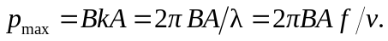
a)
b)
The amplitude at 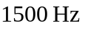exceeds the pain threshold, and at 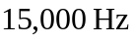 the sound would be unbearable.

